**L1**

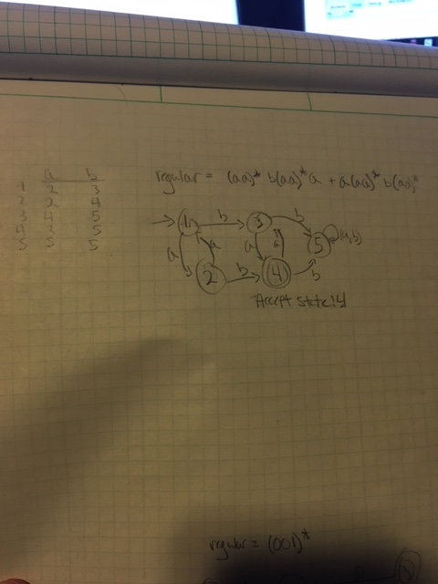

import java.util.*;  
public class TestFSM  
{  
public static void main(String[] args)  
{  
  
String A = "ab";   
int[][] ST = {{1,3,0},  
 {1,2,1},  
 {2,2,2},  
 {3,3,3}};  
int[] AS = {0,0,1,0};  
  
boolean result = false;  
  
FSM fsm = new FSM(A, ST, AS);  
  
String string1 = "aabaaaa";  
String string2 = "aaabaaaa";  
String string3 = "aabaaaab";  
String string4 = "baaaaaa";  
String string5 = "aaaaabaa";  
  
   
 result = fsm.validString(string1);  
 System.out.println("Test string: " + string1 + " Result: " + result);  
 System.out.println();  
   
 result = fsm.validString(string2);  
 System.out.println("Test string: " + string2 + " Result: " + result);  
 System.out.println();  
   
 result = fsm.validString(string3);  
 System.out.println("Test string: " + string3 + " Result: " + result);  
 System.out.println();  
   
 result = fsm.validString(string4);  
 System.out.println("Test string: " + string4 + " Result: " + result);  
 System.out.println();  
   
 result = fsm.validString(string5);  
 System.out.println("Test string: " + string5 + " Result: " + result);  
 System.out.println();  
   
   
}   
}

**Output**

▪Test string: aabaaaa Result: true  
▪  
▪Test string: aaabaaaa Result: true  
▪  
▪Test string: aabaaaab Result: true  
▪  
▪Test string: baaaaaa Result: false  
▪  
▪Test string: aaaaabaa Result: true

**L2**

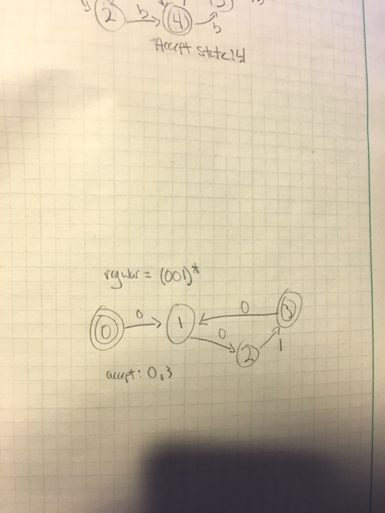

import java.util.*;  
public class TestFSM  
{  
public static void main(String[] args)  
{  
  
String A = "01";   
int[][] ST = {{1,3,0},  
 {1,2,1},  
 {2,2,2},  
 {3,3,3}};  
int[] AS = {0,0,1,0};  
  
boolean result = false;  
  
FSM fsm = new FSM(A, ST, AS);  
  
String string1 = "10";  
String string2 = "00";  
String string3 = "010";  
String string4 = "101";  
String string5 = "0100";  
  
   
 result = fsm.validString(string1);  
 System.out.println("Test string: " + string1 + " Result: " + result);  
 System.out.println();  
   
 result = fsm.validString(string2);  
 System.out.println("Test string: " + string2 + " Result: " + result);  
 System.out.println();  
   
 result = fsm.validString(string3);  
 System.out.println("Test string: " + string3 + " Result: " + result);  
 System.out.println();  
   
 result = fsm.validString(string4);  
 System.out.println("Test string: " + string4 + " Result: " + result);  
 System.out.println();  
   
 result = fsm.validString(string5);  
 System.out.println("Test string: " + string5 + " Result: " + result);  
 System.out.println();  
   
   
}   
}

**Output**

▪Test string: 10 Result: false  
▪  
▪Test string: 00 Result: false  
▪  
▪Test string: 010 Result: true  
▪  
▪Test string: 101 Result: false  
▪  
▪Test string: 0100 Result: true

**L3**

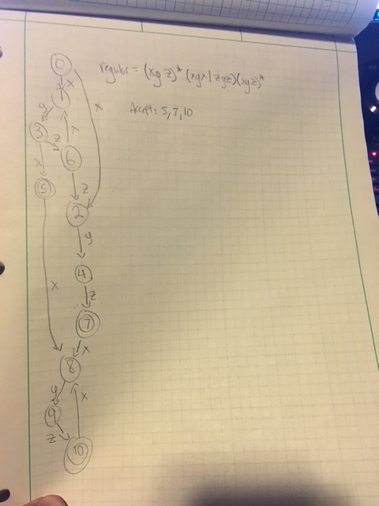

import java.util.*;  
public class TestFSM  
{  
public static void main(String[] args)  
{  
  
String A = "xyz";   
int[][] ST = {{1,3,0},  
 {1,2,1},  
 {2,2,2},  
 {3,3,3}};  
int[] AS = {0,0,1,0};  
  
boolean result = false;  
  
FSM fsm = new FSM(A, ST, AS);  
  
String string1 = "xyzyzyzy";  
String string2 = "xzzxzxyy";  
String string3 = "yzxyzyyz";  
String string4 = "zzyzxyxx";  
String string5 = "yxzxxyzy";  
  
   
 result = fsm.validString(string1);  
 System.out.println("Test string: " + string1 + " Result: " + result);  
 System.out.println();  
   
 result = fsm.validString(string2);  
 System.out.println("Test string: " + string2 + " Result: " + result);  
 System.out.println();  
   
 result = fsm.validString(string3);  
 System.out.println("Test string: " + string3 + " Result: " + result);  
 System.out.println();  
   
 result = fsm.validString(string4);  
 System.out.println("Test string: " + string4 + " Result: " + result);  
 System.out.println();  
   
 result = fsm.validString(string5);  
 System.out.println("Test string: " + string5 + " Result: " + result);  
 System.out.println();  
   
   
}   
}

**Output**

▪Test string: xyzyzyzy Result: true  
▪  
▪Test string: xzzxzxyy Result: true  
▪  
▪Test string: yzxyzyyz Result: false  
▪  
▪Test string: zzyzxyxx Result: false  
▪  
▪Test string: yxzxxyzy Result: false

**L4**

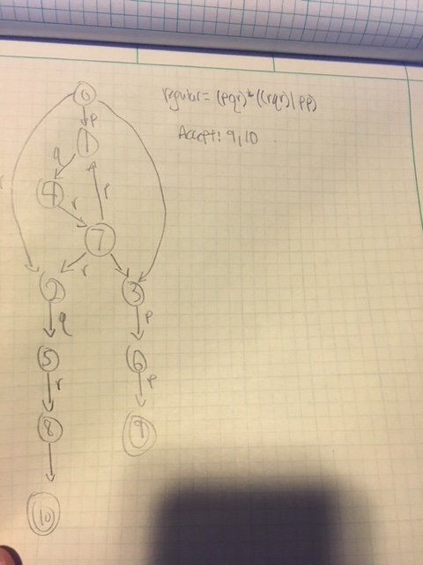

import java.util.*;  
public class TestFSM  
{  
public static void main(String[] args)  
{  
  
String A = "pqr";   
int[][] ST = {{1,3,0},  
 {1,2,1},  
 {2,2,2},  
 {3,3,3}};  
int[] AS = {0,0,1,0};  
  
boolean result = false;  
  
FSM fsm = new FSM(A, ST, AS);  
  
String string1 = "qqpprqrr";  
String string2 = "pqrprppq";  
String string3 = "rpqrrqpp";  
String string4 = "pqpprpqq";  
String string5 = "qrpprqrp";  
  
   
 result = fsm.validString(string1);  
 System.out.println("Test string: " + string1 + " Result: " + result);  
 System.out.println();  
   
 result = fsm.validString(string2);  
 System.out.println("Test string: " + string2 + " Result: " + result);  
 System.out.println();  
   
 result = fsm.validString(string3);  
 System.out.println("Test string: " + string3 + " Result: " + result);  
 System.out.println();  
   
 result = fsm.validString(string4);  
 System.out.println("Test string: " + string4 + " Result: " + result);  
 System.out.println();  
   
 result = fsm.validString(string5);  
 System.out.println("Test string: " + string5 + " Result: " + result);  
 System.out.println();  
   
   
}   
}

**Output**

▪Test string: qqpprqrr Result: false  
▪  
▪Test string: pqrprppq Result: true  
▪  
▪Test string: rpqrrqpp Result: true  
▪  
▪Test string: pqpprpqq Result: true  
▪  
▪Test string: qrpprqrp Result: false